# Topic(s): Network analytics

**Instructions**

Please share your answers filled inline in the word document. Submit Python code and R code files wherever applicable.

Please ensure you update all the details:

**Name: Batch Id:**  **Topic: Network analytics**

1. **Business Problem**
   1. **Objective**
   2. **Constraints (if any)**
2. **Work on each feature of the dataset to create a data dictionary as displayed in the below image:**

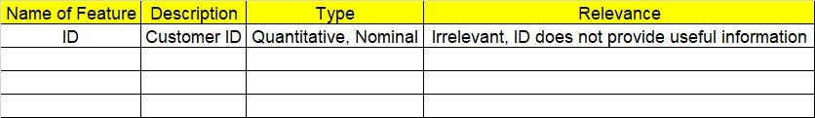

**2.1 Make a table as shown above and provide information about the features such as its Data type and its relevance to the model building, if not relevant provide reasons and provide description of the feature**

**Using R and Python codes perform:**

1. **Data Cleaning**
2. **Model Building**
   1. **Perform Network analytics on the given datasets**

**5.2Briefly explain the model output in the documentation**

**Note:**

The assignment should be submitted in the following format:

* R code
* Python code
* Code Modularization should be maintained
* Documentation of the model building (elaborating on steps mentioned above)

**Problem Statement: -**

There are two dataset consists of information for the connecting routes and flight hault. Create network analytics model on both the datasets separately and measure degree Centrality, degree of closeness centrality and degree of in-between centrality respectively.

**\*important note**

* Perform both **R and python** code for the above problem
* Create network using edge list matrix: **directed only**
* **Columns to be used in R:**

Flight_hault=c("ID","Name","City","Country","IATA_FAA","ICAO","Latitude","Longitude","Altitude","Time","DST","Tz database time")

connecting routes=c("flights", " ID", "main Airport”, “main Airport ID", "Destination ","Destination ID","haults","machinary")

**connecting routes.**

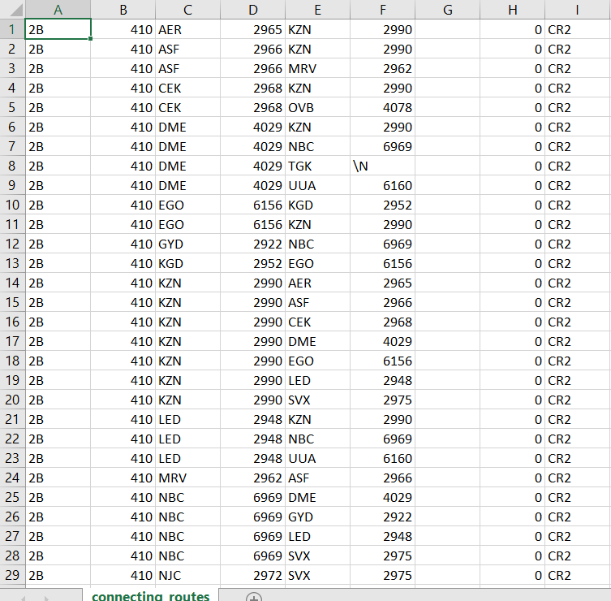



**Flight_hault1**

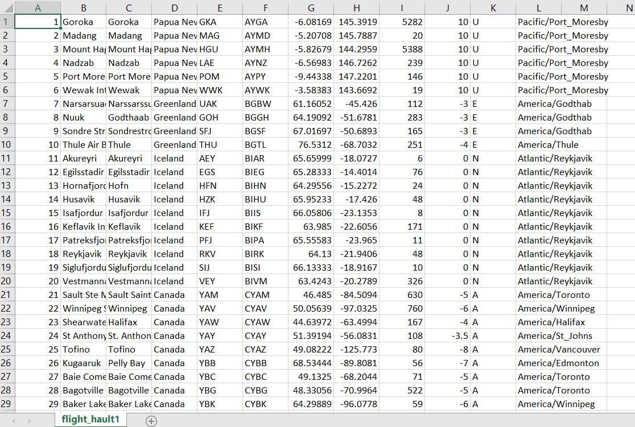

**Social network**

**Problem statement**

There are three datasets given such as Facebook, Instagram and LinkedIn. Construct and visualize the following networks:

* circular network for Facebook
* star network for Instagram
* star network for LinkedIn

**\*important note**

Perform **R code** only for the below Facebook, Instagram and Linked datasets

create a network using adjacency matrix: **undirected only, the snapshots of those datasets are given below: -**

**Facebook**

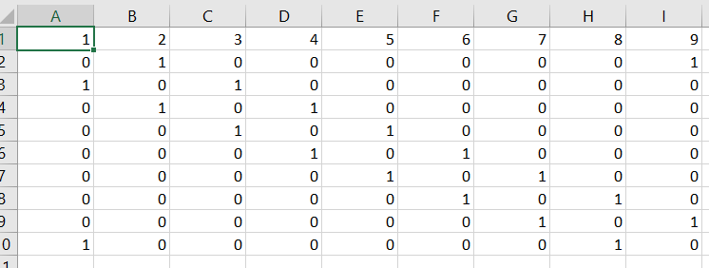

**Instagram**

**s**

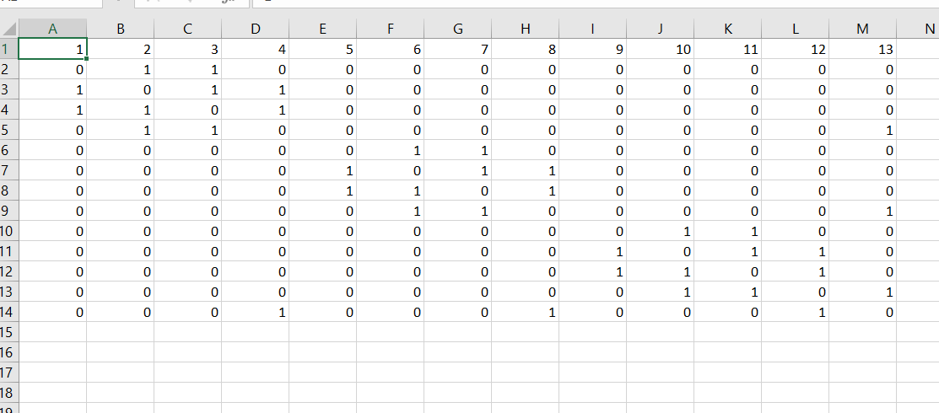

**LinkedIn**

